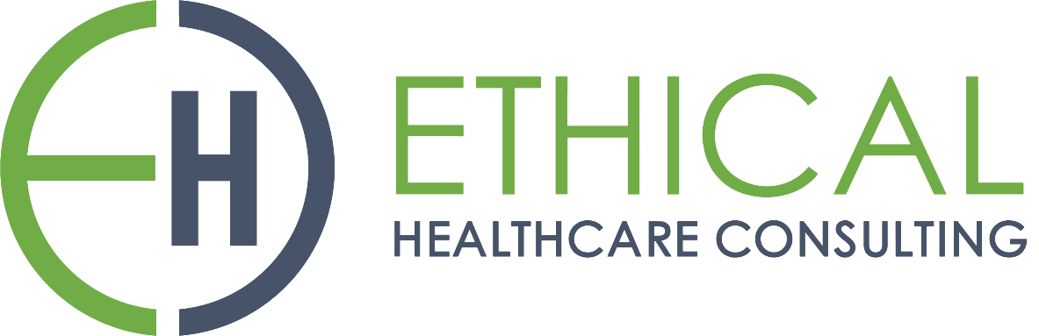

**HealthTrust Europe LLP: ITT to establish a framework agreement for consultancy solutions and advisory services Contract Notice (FTS) Ref: 2023-041574**

**Technical Response – B1_Contract Performance_Ethical Healthcare Consulting**

B1: Please describe how you will ensure that you continue to deliver the Participating Authority's requirements in line with the Specification. Your response should include:

• aligning your working methods with the Participating Authority's strategy;

• details of account management;

• frequency of contract review meetings;

• contract monitoring how Service Level Agreements and Key Performance Indicators are monitored; and

• reporting processes, ongoing monitoring for changing needs and managing feedback and readjustment.

**EHC Response:**

**• aligning your working methods with the Participating Authority's strategy;**

EHC commit to not only aligning with the operational protocols of the Trust or network we engage with but also aim to integrate improvements into these processes. This approach ensures that our collaboration is both harmonious with existing strategies and progressive, making improvements where we can.

We align our approach with our clients' preferred way of working, which is tailored to their strategic objectives. This includes accommodating their choice of tools and IT systems to ensure seamless integration and collaboration.

EHC's extensive experience and collaborative approach have allowed us to align its working methods effectively with various client strategies at Trust, Network, Regional, and National levels.

EHC's commitment to aligning with client strategies can be evidenced in collaborations with South 4 Pathology Partnership (S4) and Berkshire and Surrey Pathology Services (BSPS):

South 4 Pathology Partnership (S4):

* EHC collaborated with S4 to define an order communications strategy. This project involved understanding S4's unique needs and aligning the strategy with their objectives.
* EHC addressed multiple audit communication systems within S4, focusing on improvements that aligned with S4's strategic goals.
* EHC provided a comprehensive roadmap for future enhancements, demonstrating our commitment to not only meeting current needs but also aligning with S4's long-term strategic vision.

Berkshire and Surrey Pathology Services (BSPS):

* EHC worked closely with BSPS to define a new order communications product. This project encompassed specifying software requirements and had a substantial scope of work.
* Throughout our collaboration with BSPS, EHC ensured that the new order communications product aligned seamlessly with BSPS's strategic objectives.
* EHC's commitment to aligning with client strategies is evident in our ongoing collaboration with BSPS, where we continue to support the development and implementation of solutions that reflect their strategic vision.

In both instances, EHC's involvement went beyond mere project execution. We actively engaged with our clients to understand their strategic priorities, tailored our approach to meet their unique requirements, and ensured that the solutions we delivered aligned with their long-term goals. These collaborations exemplify our dedication to aligning with client strategies and driving outcomes that support their strategic objectives.

**• details of account management;**

EHC has a rigorous selection process to recruit experienced staff and associates. All client facing team members have experience in the NHS or consulting. References and work history are sought for all new starters. All team members are expected to understand and adhere to the Quality Policy which outlines the roles and responsibilities for key roles on projects. All individuals have a statement of work prior to commencing work which outlines their time allocation and their ownership or contribution to deliverables. As part of project kick off, EHC use delivery playbook tools and techniques to set out either a waterfall project plan or an agile sprint planning approach based on standard tooling. This includes standard project plans and status reports and other standard delivery tools which have been refined over many years and projects.

The key roles tasked with account management include:

**Sales Lead**

Initiates project scope discussions and maintains continuous involvement throughout the project lifecycle, with a primary emphasis on facilitating contract extension or expansion.

**Client Principal (CP)**

The EHC Client Principal (CP) manages client relationships across portfolios of work. Their role involves working closely with our clients to ensure we build an in-depth understanding of their needs, values, and aspirations, so that we are able to establish shared goals and where necessary align our approach and methods to properly fulfil the brief. This involves building a close rapport with clients in order to build trust. Given the role of the client principal is to work across a portfolio of work involving multiple clients, we are in a unique position where, when appropriate, we are able to share best practice or align strategies and dependencies.

The frequency of meetings between the EHC Client Principal and the contracting authority is determined by the nature and complexity of work and client needs. However, at a minimum we would expect the EHC CP to meet the client monthly. Outcomes from these sessions will be formally documented and feedback is given to the SRO and project managers.

**Senior Responsible Officer (SRO)**

A EHC Senior Responsible Officer assigned to each project who provides client, risk, commercial and quality management. These are usually an Executive Director or a Domain Lead who have typically 20+ years of experience in their area. On a weekly basis each EHC project lead completes a lightweight RAG report which flags any commercial, delivery or team issues into the SRO and to the Director of Consulting for remediation. Should there be any issues with delivery or team members, the client will have an EHC Executive Board Member to whom they can escalate. The SRO has overall responsibility for the success of the project.

**Delivery Manager**

Provides regular project progress updates, reports and communication to the client and oversees budgetary control and expenditures.

**• frequency of contract review meetings;**

Contract reviews occur at multiple intervals, and we would agree these intervals with the Participating Authority.

EHC would note however that the contract is under constant review and will be discussed during the meetings held by EHC and its customers below:

* Standups, three times a week, for ongoing alignment and adjustments.
* Retrospectives are held at the end of each two-week sprint, focusing on continuous improvement.
* Budget reviews are conducted weekly, ensuring financial alignment with project goals.
* Show and tell sessions, conducted fortnightly, serve as a platform for progress demonstration and scope validation.
* Any additional Project Board or Highlight Meetings are usually held fortnightly or monthly, depending on current diary schedules with the client.

**• contract monitoring how Service Level Agreements and Key Performance Indicators are monitored;**

EHC agrees upon specific SLAs and KPIs with the client, tailored to their unique requirements. The EHC Milestone Tracker, an example copy provided under supporting documentation, *‘****SD4 Milestone Tracker****’* and is used to ensure how EHC are performing against its targets, and Key Performance Indicators.

These reports are provided to Stakeholders on a pre-agreed basis. We use tools like highlight reports and budget review documents to track progress and adherence to the agreed actions, like the one below.

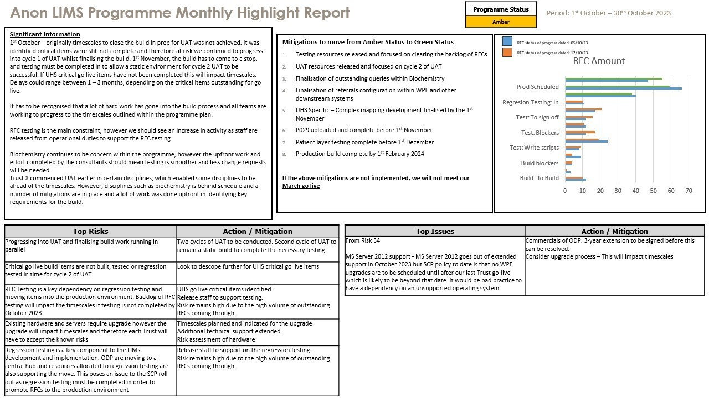

EHC also track delivery progress internally through CMAP, our project and resource management tool. The following slide is taken from the EHC Delivery Playbook provided to all our Delivery Managers and in our supporting documents *‘****SD19 Delivery Manager Playbook****’.*

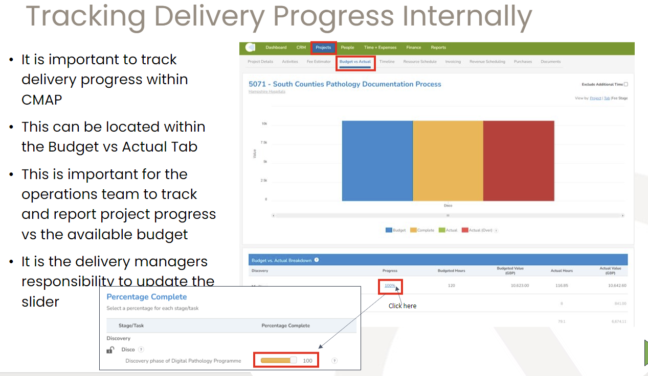

**• reporting processes, ongoing monitoring for changing needs and managing feedback and readjustment.**

Reporting Processes: EHC places a strong emphasis on robust reporting processes to ensure effective communication and transparency throughout the project lifecycle. Our reporting processes encompass various types of reports, including:

* Concise summary of project progress, highlighting key achievements, challenges, and next steps. They serve as a valuable tool for stakeholders to quickly grasp the project's status.
* Project board reports offer a detailed view of project performance, including progress against milestones, budget management, and any identified risks or issues. These reports enable stakeholders to make informed decisions and take corrective actions when necessary.
* For larger-scale projects or programs, we provide Programme board reports that offer a holistic view of multiple projects' alignment with program objectives. This comprehensive perspective ensures that projects work cohesively to achieve overarching goals.
* Visual representations of project timelines, Gantt charts help stakeholders understand project schedules, dependencies, and critical paths. These charts enhance project planning and execution by providing a clear roadmap.
* Additionally, we enhance transparency by providing burn-down rates extracted from our tool, Jira, allowing stakeholders to track progress in real-time.
* Our resource management and scheduling tool, CMAP, play a pivotal role in forecasting and managing project resources efficiently. It empowers our Delivery Managers to identify future resource requirements, manage costs effectively, and provide a clear view of budget implications.

Our Delivery Manager ensures prompt flagging of challenges and puts appropriate mitigations and communication plans in place. An example of this is given below:

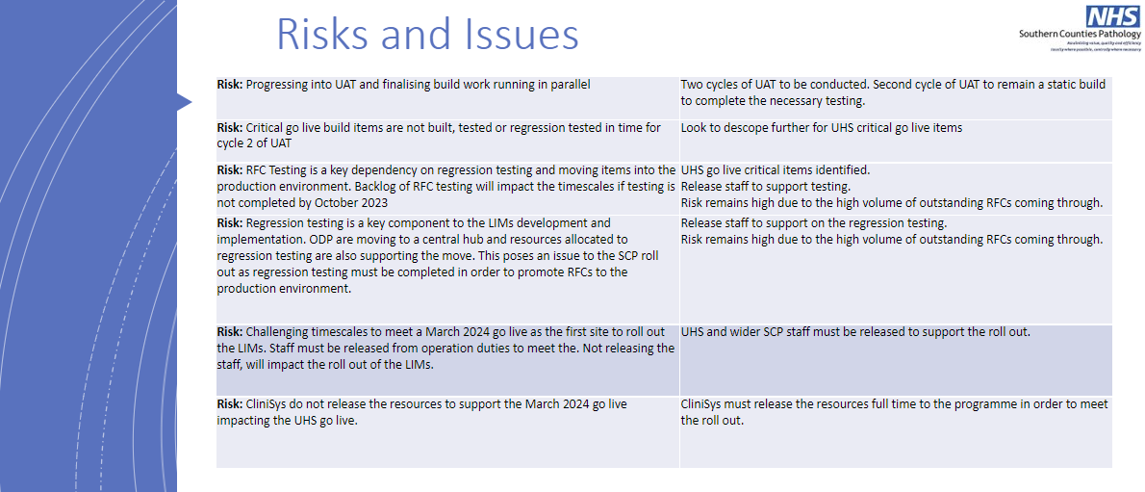

Ongoing Monitoring for Changing Needs: EHC's approach to ongoing monitoring is proactive and integrated into the project plan from the outset. We assign relevant stakeholders, whether internal or external, to monitor various aspects of the project. This approach includes:

* Recognising that project dynamics can change, and we are agile in our response. Feedback related to service levels, budget management, and project milestones is continually assessed, and adjustments are made as needed to ensure project success.
* We quickly identify and assess any delays or challenges as soon as they occur, enabling us to take corrective actions promptly.
* Our commitment to clear and honest communication means that we inform the Participating Authority about delays, their root causes, and our proposed solutions. This ensures transparency and alignment of expectations.
* We conduct thorough root cause analysis to determine the source of delays, whether they originate from our side, the Authority's, or a third party's. This analysis informs our corrective actions.
* We engage in discussions with the Authority to refine our approach

Managing Feedback: EHC's commitment to managing feedback is ingrained in our project management practices, and Feedback from clients and staff is actively sought and acted upon. We employ several strategies to effectively manage feedback, including:

* We engage key stakeholders and our project teams through regular and structured meetings, whether virtual or on-site. These meetings provide platforms for detailed discussions, presentations, and the exchange of feedback.
* We maintain a comprehensive record of all meeting minutes and feedback, accessible to both EHC and the client. Any feedback received is thoroughly reviewed and discussed by the project teams responsible for contract management, as well as our senior leadership. This proactive approach ensures that both positive and negative feedback are addressed promptly and effectively. In cases where specific actions are required, we follow the guidelines outlined in ‘***SD8 EHC Complaints Procedure and Corrective and Preventative Action Procedure***’ to guide our response and resolution processes.
* Change Control Notes (CCNs) are an essential part of our governance process to prevent scope creep and manage changes to the project scope. We document CCNs in the MS Project Folder, ensuring that changes are tracked, reviewed, and approved as needed.
* After resolving any issues or challenges, we conduct reviews to learn from the experiences and improve our processes for future projects. This commitment to continuous improvement ensures that we enhance our delivery practices over time.